Orion Dorset and Wiltshire Fire Service

Wide area building fire monitoring and alert system.

Background
There are many different set ups in buildings when it comes to fire systems. In some blocks of flats there are individual fire alarms but no communal alarms. (The reason being that it is too easy for pranksters to set off a communal alarm and because of the construction of the building, the aim has always been to contain the fire in a single apartment.) In other blocks, there are linked smoke alarms, but smoke alarms do not always give a desire response as they are subject to over alerting due to burning food items for example, but no heat sensors. The solution outlined here is a simple, flexible, low cost way to retrospectively fit different types of alarm quickly to an existing building. The aim being to reassure residents and provide a clear message from the respective housing authority that proactive measures are being undertaken to ensure the safety of inhabitants.

The Solution
To retrospectively fit a sprinkler system is expensive and time consuming. A more immediate option to protect people in the building is to put in a wireless alarm system. This can use heat, smoke or even flame detectors as the trigger. The unique twist here is that there is no control panel, instead the solution connects to a server that in turn talks to the residents, local fire service and housing management in near real time allowing an immediate and effective response to potential threats to the welfare of the inhabitants.
As the Orion system is entirely wireless, it is quick and easy to install. When a sensor goes off, it will trigger a local alarm. It will also notify the server of the activation so that a schedule of messages can be sent to residents. The messaging can be by flat or by floor or to the entire building, but more importantly, it can be customised to identify which tag has been activated so that the fire service will have an immediate response plan ameliorating the time it takes to identify where the fire has taken place. If a tag is activated it will inform the fire service and management which flat has alerted increasing the effectiveness of an evacuation procedure, something that a traditional smoke alarm will be unable to achieve.
If there is a fire the residents can call the fire brigade as normal. There is also have the option of using the system to let everyone in the building know there is a fire and to begin the evacuation. Anyone who is unable to exit the building can also provide the system with the fact they are stuck in their flat. This means that the first responders can immediately prioritise those who need help evacuating.

The Architecture
The Orion system in the building is entirely wireless but the gateways need power and Ethernet. Usually there are only a small handful of gateways per building. These are the hubs of the radio system. The sensors are all well-known makes and models that are Orion enabled. These can be anything from smoke, heat or flame type sensors through to man down or panic buttons.
Each building is installed in around a day and the software control is implemented and tested. If residents want alerts then the system needs their mobile numbers. (Tests have shown that whilst people will ignore alarms, buzzers and road noise, they will respond to messages on phones because they are tuned into their devices). For residents without mobile devices, individual sirens or buzzers can be fitted, wirelessly to their flats. The system is therefore adaptable and flexible to different individual requirements whilst still using the same overall architecture.
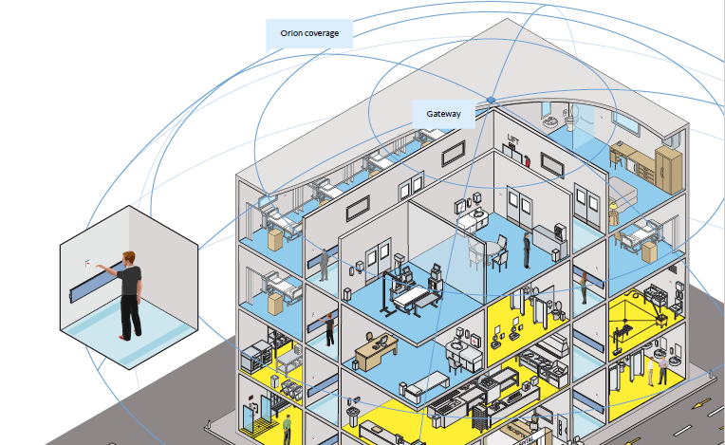

Added benefits of Orion

One of the key benefits of the Orion system is the ability to add tags to an existing network. Once the infrastructure, a gateway on top of a building, has been installed, there are a multitude of other functions that can be added to your network. All Orion tags are independent of gateways, this means that tags can be installed in vehicles and assets, ID badges or panic alarms for employees, or just simply in other product forms such as on fire doors.
In this case, a further layer of security for an evacuation process could be panic buttons on the inside of flats to indicate which residents have left their properties but this is not fool proof as there is no way of knowing if they are still in the communal areas (hallways) and not at the evacuation point. However, a simple role call system at a muster point will alleviate such issues.

The objective is simple and easy to implement. New Forest Communications (NFC group) have been working closely with Dorset and Wiltshire Fire and Rescue Service (DWFRS) over the last 12 months by providing a personal data network to provide first line alerting for their PPS misting units to aid in reducing fire deaths relating to vulnerable persons within the community.
Once the network has been installed, NFC group will undertake a systematic approach for deploying heat sensor units, with each flat being fully integrated and online within the working day. To aid efficiency, all recipients of alerts will need to be determined prior to installation, and access will be required to each dwelling on the day of installation.

Conclusion

The need for real-time alerting from fire based monitors in housing communities has now become an immediate and effective way to lessen the risk to occupants within these buildings. The Orion network fulfils various objectives in this respect, providing many options within its functionality, but most importantly by providing the initial alert at the earliest point in the onset of a potential fire. The Orion network and sensors can be deployed immediately and easily, providing ……….. with added assurance that occupants of their buildings are reassured, and that by using innovative technologies, ensuring their buildings are utilising effective systems for targeted response mechanisms.

